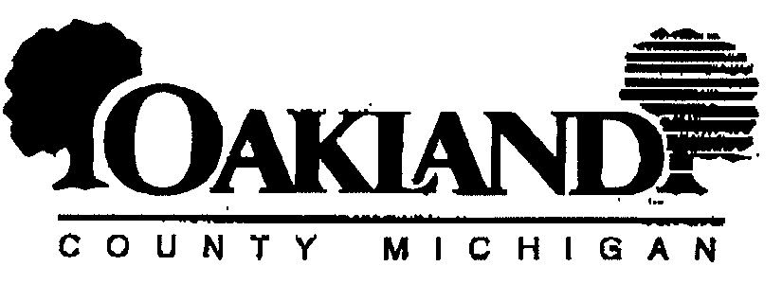

OAKLAND COUNTY GOVERNMENT
INTERAGENCY CONSENT AND AUTHORIZATION
TO RELEASE PROTECTED HEALTH INFORMATION

1. I grant permission to (check one or more):
◻ Circuit Court-Family Division ◻ DHS/Children’s Village ◻ Medical Examiner
◻ Community Corrections ◻ DHS/Health Division ◻ Employment & Training
◻ Community Mental Health ◻ DHS/Medical Care Facility ◻ FIA-Oakland
◻ Other (specify)________________________________________________________________________________

To release information on:
Name of Person: Lila Johnson DOB or SS#: 11/13/1956 / XXX-XX-3296
2. This information may be released to the following (check one or more):
◻ Circuit Court-Family Division ◻ DHS/Children’s Village ◻ Medical Examiner
◻ Community Corrections ◻ DHS/Health Division ◻ Employment & Training
◻ Community Mental Health ◻ DHS/Medical Care Facility ◻ FIA-Oakland
☑ Other (specify) Axiom Requisition Copy Service fka ACRC Requisition Copy Svs, 447 North Canal Road, Lansing, MI 48917
3. What information may be released:
FROM 11/13/1956 TO PRESENT: Any and all MEDICAL RECORDS pertaining to Lila Johnson SSN: XXX-XX-3296, DOB: 11/13/1956.
4. For what purpose is the information to be released:
◻ To assist in the coordination and/or provision of services.
☑ Other (specify) This authorization for release of my health information is provided in connection with the legal action Johnson v Sandra Ann Thomas, in which allegations of wrongful conduct, damage or loss have been made making the above information discoverable under state law and authorizes the Receiving Party to use and disclose this health information for any and all purposes associated with this legal action.
- I understand that I have a right to receive a copy of this document.
- I understand that I may withdraw this consent by written notification received by the agency head at any time before information is released. I also understand that disclosure of the above protected health information may be subject to redisclosure by the recipient and, therefore, may no loner be protected. I further understand that redisclosure of substance abuse-related information by the recipient is prohibited unless authorized by 42 CRF, Part 2.
- Unless withdrawn in writing this consent expires as follows:
- Date: Twelve (12) months from the date of signature
- Event: The end of the legal action Johnson v Sandra Ann Thomas
- Condition: _________________________________________________________________________________________
*NOTE: AIDS-related information (i.e., HIV, ARC, AIDS) and/or psychotherapy notes shall not be released unless specifically listed under Item #3 above.
__________________________________________________________ _____________________________________________
Client/Parent/Guardian Signature (Relationship) Date
__________________________________________________________ _____________________________________________
Witness Signature Date
This authorization is consistent with standards established under 42 CRF, Part 2; 45 CRF, Parts 160 and 164; and Michigan Law. No Oakland County agency may release protected health information without a current valid written authorization in its possession or as otherwise provided by law.
DHS 4/03 (Revised)
Order No. 01-12722 - 003 -- Contact: Vicki Lintemuth

